Date and Time Handling Concepts

1.Day of the Year
class Solution {
public int dayOfYear(String date) {
int year = Integer.parseInt(date.substring(0, 4));
int month = Integer.parseInt(date.substring(5, 7));
int day = Integer.parseInt(date.substring(8, 10));

int[] daysInMonth = {
31, 28, 31, 30, 31, 30,
31, 31, 30, 31, 30, 31
};

// Check leap year
if ((year % 400 == 0) || (year % 4 == 0 && year % 100 != 0)) {
daysInMonth[1] = 29;
}

int result = day;

for (int i = 0; i < month - 1; i++) {
result += daysInMonth[i];
}

return result;
}
}
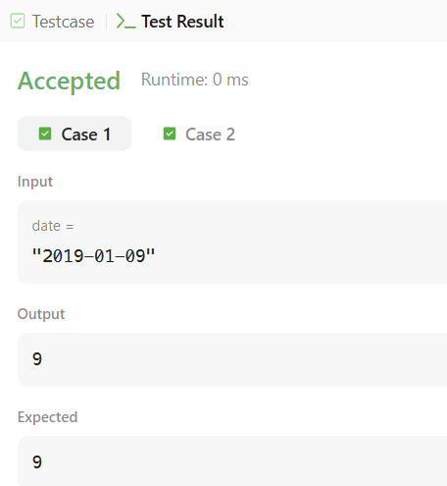
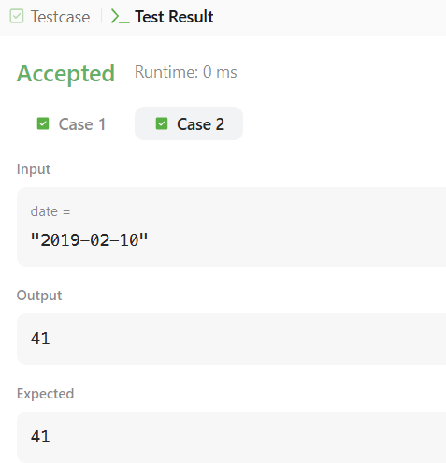

2. Day of the Week
class Solution {
public String dayOfTheWeek(int day, int month, int year) {

String[] week = {
"Sunday", "Monday", "Tuesday",
"Wednesday", "Thursday", "Friday", "Saturday"
};

int[] days = {
31, 28, 31, 30, 31, 30,
31, 31, 30, 31, 30, 31
};

int total = 0;

for (int y = 1971; y < year; y++) {
if ((y % 400 == 0) || (y % 4 == 0 && y % 100 != 0))
total += 366;
else
total += 365;
}

for (int m = 1; m < month; m++) {
total += days[m - 1];

if (m == 2 &&
((year % 400 == 0) || (year % 4 == 0 && year % 100 != 0))) {
total++;
}
}

total += day;

return week[(total + 4) % 7];
}
}
